Chris Geeson BA CPFA FSLCC
7 Chariot Way
Thorpe Audlin
Pontefract
WF8 3EZ

Dunham & District Parish Council

Internal Auditors Report

As the appointed auditor to the Town Council I confirm that I have examined the accounting information for the financial year ended 31st March 2018.

In connection with my examination no matter has come to my attention: -

- Which gives me reasonable cause to believe that in any material respect, the requirements to keep accounting records in accordance with generally accepted principles have not been met, or
- To which, in my opinion, attention should be drawn in order to enable a proper understanding of the accounting information to be reached.

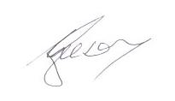

Chris Geeson BA CPFA FSLCC
Internal Auditor

Dated 14 June 2018

